## Instalação do Servidor Chef

1. yum update –y

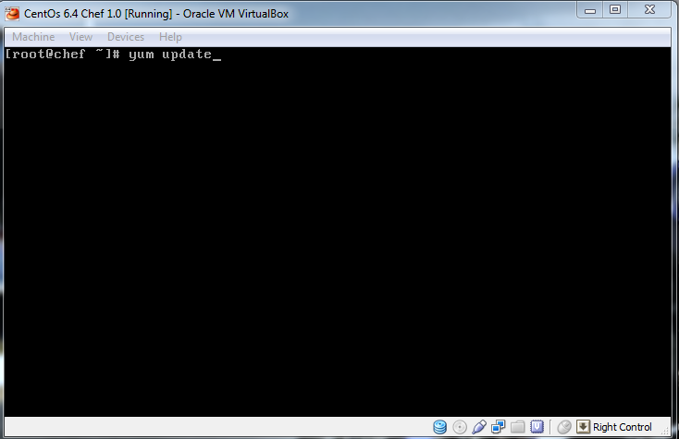

1. rpm -Uvh <http://rbel.co/rbel6>

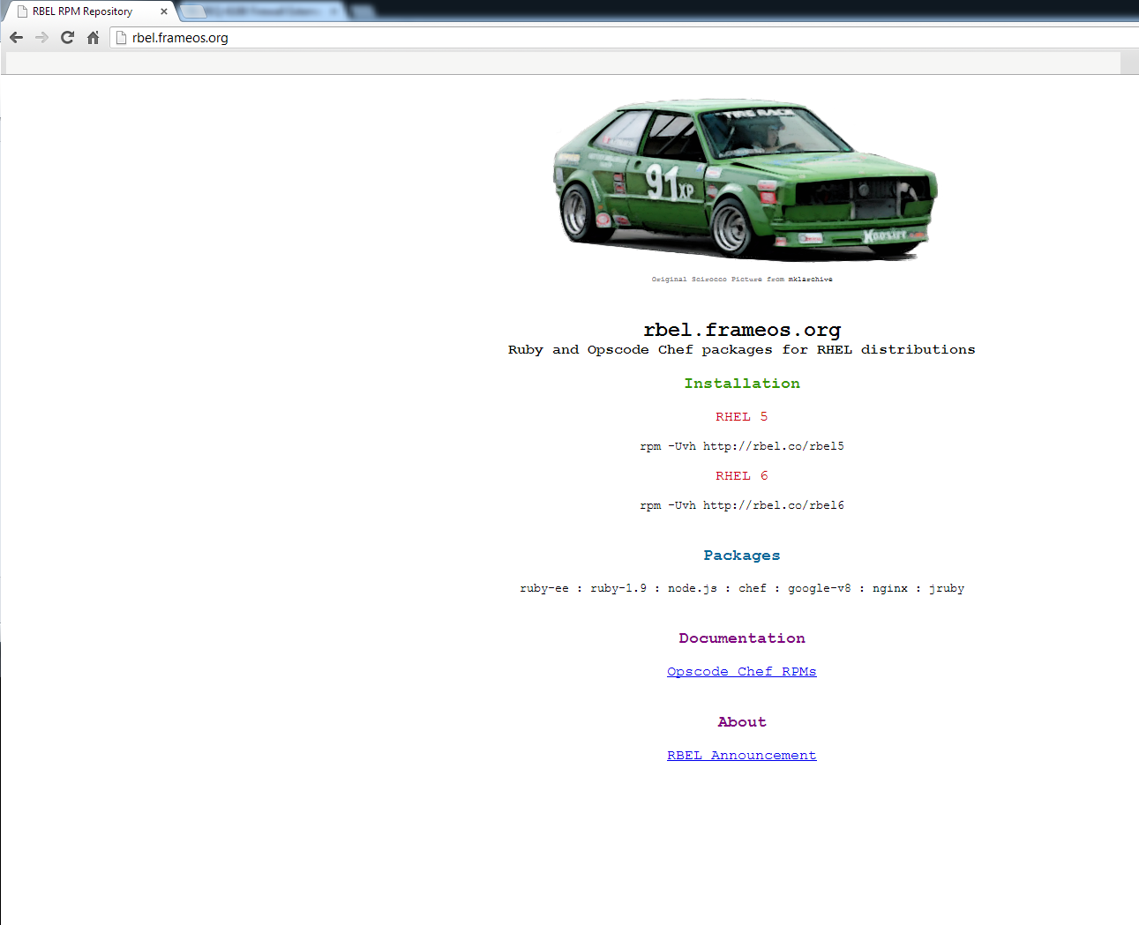

1. Verificar qual Kernel do servidor 32 bytes ou 64 bytes   
   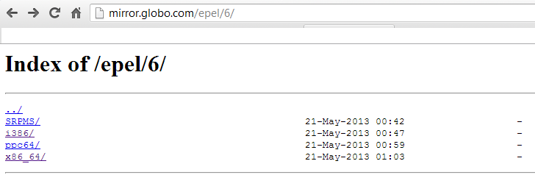  
   (32 bytes) rpm -Uvh <http://download.fedoraproject.org/pub/epel/6/i386/epel-release-6-8.noarch.rpm>  
   (64 bytes) rpm -Uvh <http://mirror.globo.com/epel/6/x86_64/>epel-release-6-8.noarch.rpm
2. yum install -y gcc gcc-c++ automake autoconf make curl dmidecode unzip sudo
3. yum install -y rubygem-chef-server ruby-shadow --enablerepo=epel
4. service iptables stop
5. setup-chef-server.sh
6. knife configure -i -u admin
7. Arquivos de Configuração.  
   /etc/chef/  
   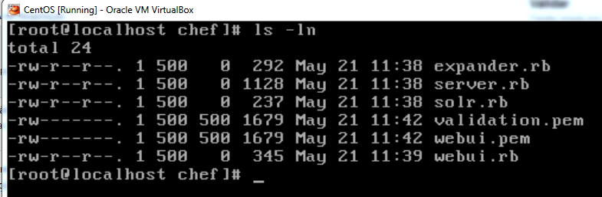

## *Installing Chef Server 0.10 in RHEL 6*

*By [rubiojr](http://blog.frameos.org/author/admin/" \o "Posts by rubiojr) on May 19, 2011*

Opscode **Chef 0.10.0** client/server packages for RHEL6 distributions are now available at [rbel.frameos.org](http://rbel.frameos.org/) **Installing a RHEL 6 based Chef Server** 1. Install the RBEL repo

rpm -Uvh http://rbel.frameos.org/rbel6

2. Install Chef Server and dependencies

yum install rubygem-chef-server

3. To make things easier, disable the firewall (Don’t do it in a production or public facing server)

service iptables stop

4. Run the setup script

setup-chef-server.sh

Now login to http://your-chef-server:4040 **user:** admin **password:** chef321go

Iniciar o chef acessar

git clone git://github.com/opscode/chef-repo.git /var/chef/cookbooks

Knife

knife cookbook upload /var/chef/cookbooks –all

knife cookbook site install firefox

knife cookbook upload /var/chef/cookbooks –all

knife node list

knife recipe list

knife cookbook upload -a

knife node edit (WIN-B3JI3RVRCHJ)

usar o editor vim pro knife (export EDITOR=vim)  
(colocar cliente no novo servidor) knife bootstrap –x root ipservidor –d centos6-gems

knife bootstrap ipservidor –d centos6-gems add –r ‘recipe[mysql::default]’

bootstrap  
/usr/lib/ruby/gems/1.8/gems/chef-0.10.6/lib/chef/knife/bootstrap

** BOOTSTRAP COMMANDS **

knife bootstrap FQDN (options)

** CLIENT COMMANDS **

knife client bulk delete REGEX (options)

knife client delete CLIENT (options)

knife client reregister CLIENT (options)

knife client show CLIENT (options)

knife client list (options)

knife client create CLIENT (options)

knife client edit CLIENT (options)

** CONFIGURE COMMANDS **

knife configure (options)

knife configure client DIRECTORY

** COOKBOOK COMMANDS **

knife cookbook test [COOKBOOKS...] (options)

knife cookbook create COOKBOOK (options)

knife cookbook show COOKBOOK [VERSION] [PART] [FILENAME] (options)

knife cookbook bulk delete REGEX (options)

knife cookbook list (options)

knife cookbook metadata COOKBOOK (options)

knife cookbook upload [COOKBOOKS...] (options)

knife cookbook delete COOKBOOK VERSION (options)

knife cookbook metadata from FILE (options)

knife cookbook download COOKBOOK [VERSION] (options)

** COOKBOOK SITE COMMANDS **

knife cookbook site unshare COOKBOOK

knife cookbook site install COOKBOOK [VERSION] (options)

knife cookbook site search QUERY (options)

knife cookbook site show COOKBOOK [VERSION] (options)

knife cookbook site list (options)

knife cookbook site download COOKBOOK [VERSION] (options)

knife cookbook site share COOKBOOK CATEGORY (options)

** DATA BAG COMMANDS **

knife data bag list (options)

knife data bag show BAG [ITEM] (options)

knife data bag from file BAG FILE (options)

knife data bag delete BAG [ITEM] (options)

knife data bag edit BAG ITEM (options)

knife data bag create BAG [ITEM] (options)

** ENVIRONMENT COMMANDS **

knife environment create ENVIRONMENT (options)

knife environment show ENVIRONMENT (options)

knife environment from file FILE (options)

knife environment delete ENVIRONMENT (options)

knife environment list (options)

knife environment edit ENVIRONMENT (options)

** EXEC COMMANDS **

knife exec [SCRIPT] (options)

** HELP COMMANDS **

knife help [list|TOPIC]

** INDEX COMMANDS **

knife index rebuild (options)

** NODE COMMANDS **

knife node show NODE (options)

knife node edit NODE (options)

knife node run_list add [NODE] [ENTRY] (options)

knife node delete NODE (options)

knife node bulk delete REGEX (options)

knife node create NODE (options)

knife node run_list remove [NODE] [ENTRY] (options)

knife node from file FILE (options)

knife node list (options)

** RECIPE COMMANDS **

knife recipe list [PATTERN]

** ROLE COMMANDS **

knife role delete ROLE (options)

knife role create ROLE (options)

knife role from file FILE [FILE..] (options)

knife role show ROLE (options)

knife role edit ROLE (options)

knife role list (options)

knife role bulk delete REGEX (options)

** SEARCH COMMANDS **

knife search INDEX QUERY (options)

** SSH COMMANDS **

knife ssh QUERY COMMAND (options)

** STATUS COMMANDS **

knife status QUERY (options)

** TAG COMMANDS **

knife tag create NODE TAG ...

knife tag delete NODE TAG ...

knife tag list NODE

knife bootstrap  
/usr/lib/ruby/gems/1.8/gems/chef-0.10.6/lib/chef/knife/bootstrap

Comandos novos